**emplate T**

**Empathy map canvas**

Use this framework to empathize with a customer, user, or any person who is affected by a team’s work.

Document and discuss your observations and note your assumptions to gain more empathy for the people you serve.

Originally created by Dave Gray at

[**Share template feedback**](https://muralco.typeform.com/to/CiqaHVat?typeform-source=app.mural.co)

**Need some inspiration?**

See a finished version of this template to kickstart your work.

[**Open example**](https://app.mural.co/template/018339d6-ff71-42d8-9e5c-abddde77d5ab/982236e0-c7e5-4fb6-83e9-ef1b972b25bd)

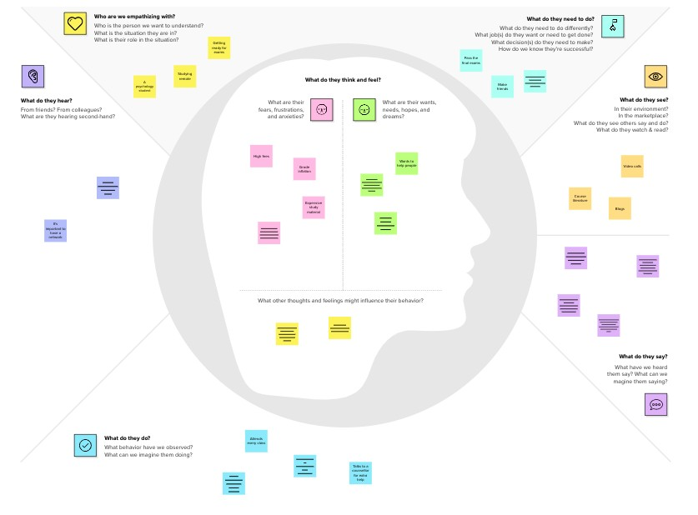

✴

**Develop shared understanding and empathy**

Summarize the data you have gathered related to the people that are impacted by your work. It will help you generate ideas, prioritize features, or discuss decisions.

**WHO are we empathizing with?**

Who is the person we want to understand? What is the situation they are in?

What is their role in the situation?

**GOAL**

**What do they need to DO?**

What do they need to do differently? What job(s) do they want or need to get done? What decision(s) do they need to make?

How will we know they were successful?

**What do they THINK and FEEL?**

**What do they HEAR?**

What are they hearing others say? What are they hearing from friends? What are they hearing from colleagues? What are they hearing second-hand?

**PAINS**

What are their fears, frustrations, and anxieties?

**GAINS**

What are their wants, needs, hopes, and dreams?

This is a title...

very useful this project

What other thoughts and feelings mi

**What do they DO?**

What do they do today?

What behavior have we observed? What can we imagine them doing?

**What do they SAY?**

What have we heard them say? What can we magine them saying?

ght influence their behavior?

**What do they SEE?**

What do they see in the marketplace? What do they see in their immediate environment? What do they see others saying and doing?

What are they watching and reading?

Ability to emotionally understand what other people feel

to get a good job

easy method

Achieve the good position in career

Today expectancy in the banking service delivery is in terms of leveraging intelligent and seamless digital experiences.

Helps us understand how others are feeling

It does not only maintained but also strengthen their position in the market

Empathetic banks that get this right outperform their peers

Empathy isn't just admirable and necessary individual trait

Just 3 in 10 banks are very confident that they can sends customers emotional outlook about their financial situation

Banker going to need to find digital ways to build

lessons are expensive

Error must be point out

She will not learn the lamguage

She dreams of travelling

Make empathy part of the digital skillset

interesting project and learning more things try to better position

Deliver personalized customer experiences and grow your business

When they are get a good position

Empathy means when you see another person suffering

Get asoftware enginnering